Tay’s Cakes:
Thank you for choosing Tay’s Cakes to celebrate your event. Tay’s Cakes specializes in custom baked treats made with love and care with the goal of exceeding customer expectations. This document will go over pricing and other important details for the order. For any questions or concerns please do not hesitate to contact Taylor at either of the options below.
Email: tayscakes0309@gmail.com
Text: (303) 917 – 3966

TERMS AND PRICING:
- Upfront Payment:
An upfront payment of at least 50% of the total will be due at time of order to book the date. This will be part of the total cost and is non-refundable in case of cancellations. The rest of the payment will be due a week before the event (for weddings and orders over $175) and the day before pickup for all other orders but can be paid anytime earlier.

- Presentation:
Tay’s Cakes is not responsible for damage of any kind to the order once it is out of the baker’s possession. The buyer holds the responsibility of providing an appropriate environment for the order. This includes but is not limited to transportation, the weight of the order and temperature/environmental conditions. There is no guarantee that any item will withhold specific temperatures. Tay’s Cakes is not responsible for damage of any kind from mishandling and/or climates that do not support the order’s items (including outdoor temperatures).

- Tastings:
A $30.00 amount will be added to the final pricing if a cake tasting is requested. Each tasting box will include up to 3 flavors and will be for two people. More people are welcome to participate in the tasting but the amount of cake provided will stay the same. This payment will be due at the time of booking the tasting.

- Delivery:
Tay’s Cakes is unable to provide delivery at this time.
If by chance we are able to deliver, there is a delivery fee of $40.00 with an additional $0.65/mile x 2 outside of a 20-mile radius of the baker’s location.

- Rentals:
Tools and rentals are not included in the order. If available upon request, rentals such as utensils and stands can be rented at $15/rental piece. Rentals must be returned, clean and in the same condition when they were received. Rentals must be returned within two days of the event. $10/day will be added if it is not received by the second day until it is returned.

- Cancellation Policy
Orders cancelled two weeks before the event date can be refunded any payments that were in addition to the 50% non-refundable payment. Tasting boxes that have already been made/sent out will not be refunded.

**For any questions regarding the terms and policies, please do not hesitate to contact me. **

PRICING:
** All pricing is based on a starting price then changed based on size, flavor, fillings, add ons, and design of each custom baked item. No baked good is the same so pricing may change based on customizations. **

** Price by serving is based on 1” x 2” cut sizes **

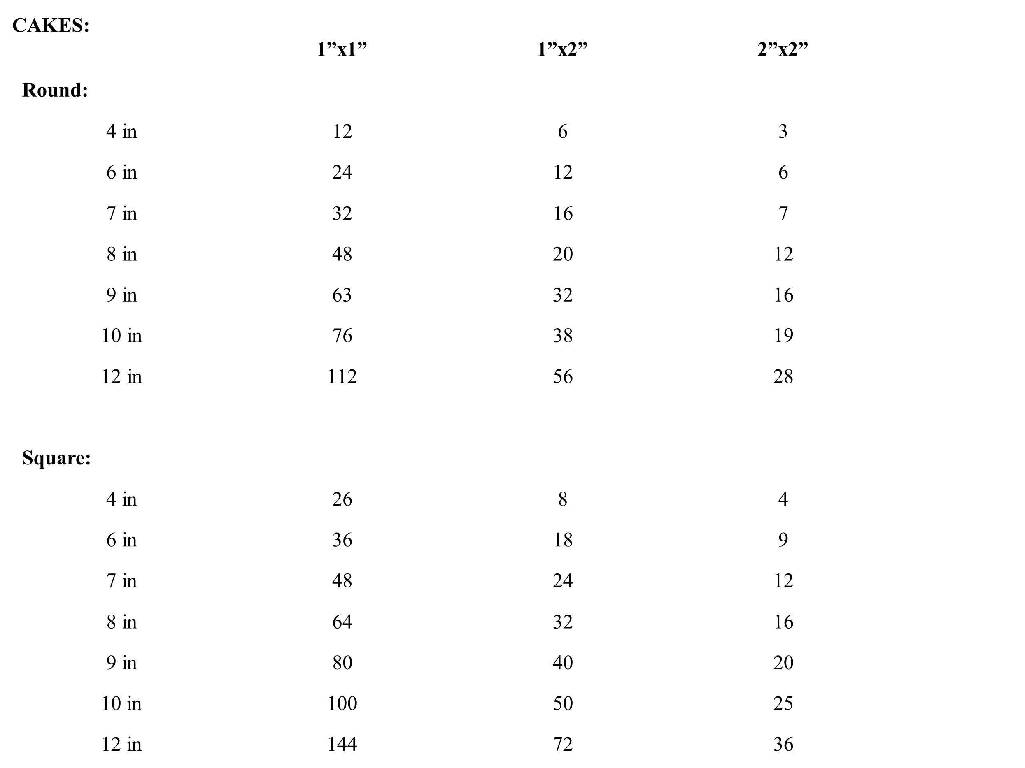

- Basic Cake Starting Prices
4 in – (only available with existing order of the same flavor) $45
6 in - $65
7 in - $75
8 in - $90
9 in - $110
10 in - $140
12 in - $165

** Custom fondant cake toppers start at $25.
** Cake fillings ($.50/serving, added to starting cake price)
** Specialty Cake flavors (.50/serving, added to starting cake price).
** Fondant/ Custom detail cakes ($.75/serving, added to starting cake price)
- Basic wedding or tiered cakes (price includes 2 tiers- each tier after that goes up $.50/serving)
$5/serving- additional charges for specialty flavors and/or fillings
- Custom, Fondant, or Detailed wedding or tiered cakes (price includes 2 tiers- each tier after that goes up $.50/serving)
$5.75/serving- additional charges for specialty flavors and/or fillings.

CUPCAKES:
- Regular cupcakes (base price)
$45/dozen
Minimum order of 1 dozen cupcakes
1 flavor per dozen cupcakes
Fillings add $.50/cupcake
Specialty flavors add $.50/cupcake

- Mini cupcakes (base price)
$45/2 dozen
Minimum order of 2 dozen cupcakes
1 flavor per 2 dozen cupcakes
Fillings add $.25/cupcake
Specialty flavors add $.25/cupcake

- Jumbo cupcakes (base price)
$45/half dozen
Minimum order of half dozen cupcakes
1 flavor per half dozen cupcakes
Fillings add $.50/cupcake
Specialty flavors add $.50/cupcake

- Small decorations (amount below added to price of cupcakes)
$.75/ regular or jumbo cupcake
$.30/mini cupcake

- Custom, fondant, or detailed decorations (amount below added to price of cupcakes)
$2.50/regular or jumbo cupcake
$2/ mini cupcake

COOKIES:

- Classic cookies
$30/dozen
Minimum of 1 dozen cookies
One flavor per dozen

- Specialty cookies
$36/dozen
Minimum of 1 dozen cookies
One flavor per dozen

- Custom decorated Sugar Cookies
$55/dozen – Starting price
** Price changes based on designs and details
Minimum order of 1 dozen cookies

CHOCOLATE COVERED TREATS:

- Cake Pops
$40/dozen (Starting price)
Minimum of one dozen
One flavor per dozen
Price can increase based on design

- Chocolate covered strawberries
$40/dozen
Ordered by half or full dozen
Classic chocolate or white chocolate dipped

- Hot Cocoa Bombs
Prices starting at $5.50/cocoa bomb
Sold individually or in packs

BREADS:

- Bread loaves:
$15/loaf



